Advanced Algebra 2 Name: _______________________ Period: ________
Unit 2A Test
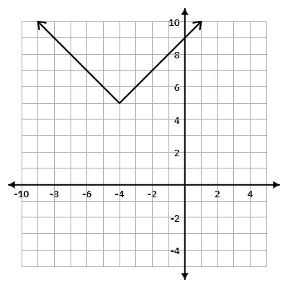
Using the graph provided answer the questions 1-9:
1. The domain of the function is:
A. $(-∞, -4]$ B. $(-∞, 4)$
C. $(-∞, ∞)$ D. $[4, ∞)$
2. The range of the function is:
A. $(5, ∞]$ B. $(-∞, ∞)$
C. $[5, ∞)$ D. $(5, ∞)$
3. The function has a minimum at $(-4, 5).$
A. True B. False
4. The vertex of the function is:
A. $(-4,5)$ B. $(4,5)$ C. $(-5,4)$ D. $(-4, -5)$
5. The x-intercepts are (circle all that apply):
A. $(9,0)$ B.$(0, 9)$ C. $(0,0)$ D. none
6. The axis of symmetry is:
A. $y=-4$ B. $y=9$ C. $x=9$ D. $x=-4$
7. The y-intercept is:
A. $(9,0)$ B. $(8,0)$ C. $(0, 9)$ D. $(-9, 0)$
8. The equation of the function is:
A. $f(x)=\left|x-4\right|+5$ B. $f(x)=-\left|x+4\right|+5$
C. $f(x)=\left|x+4\right|+5$ D. $f(x)=\left|x-4\right|-5$
9. The verbal description is:
A. Reflect over y-axis, Shift down 5, Shift Right 4, Vertical Stretch by 2.
B. Reflect over x-axis, Shift up 5, Shift Right 4, Vertical compression by $\frac{1}{2}$.
C. Shift up 5, Shift Left 4,
D. Shift up 5, Shift Left 4, Vertical compression by $\frac{1}{2}$.
Using the equation provided answer the questions 10-17:
$f(x)=-\frac{1}{2}\left|x+5\right|-2$
10. The function notation description is:
A. $f(x)=-\frac{1}{2}\left|x+5\right|-2$ B. $-\frac{1}{2}f(x+5)-2$
C. $f-\frac{1}{2}(x+5)-2$ D. $\frac{1}{2}f-(x+5)-2$
11. Provide the verbal description of this function on your answer sheet.
12. Graph this function on your answer sheet.
13. The vertex of the function is:
A. $(-2,-5)$ B. $(5,-2)$ C. $(-2, 5)$ D. $(-5,-2)$
14. The domain of the function is:
A. $(-∞, ∞)$ B. $[5, -∞)$ C.$(5,-∞)$ D. $(-∞,-2]$
15. The range of the function is:
A. $(-∞, ∞)$ B. $[5, -∞)$ C.$(5,-∞)$ D. $(-∞,-2]$
16. This function has a minimum of (-5, -2).
A. True B. False
17. Provide the axis of symmetry on your answer sheet.

Given a description of a function, choose the correct equation.
18. A function is compressed vertically by $\frac{1}{4}$, shifted left 4 units and up 7 units.
A. $f(x)=\frac{1}{4}\left|x-4\right|+7$ B. $f(x)=4\left|x-4\right|-7$
C. $f(x)=4\left|x+4\right|+7$ D. $f(x)=\frac{1}{4}\left|x+4\right|+7$

19. A function is reflected over the x-axis, stretched vertically by 3, shifted right 2 units and down 4 units.
A. $f(x)=-\frac{1}{3}\left|x+2\right|-4$ B. $f(x)=-3\left|x+2\right|-4$
C. $f(x)=-\frac{1}{3}\left|x-2\right|-4$ D. $f(x)=-3\left|x-2\right|-4$

Using the equation provided answer the questions 20-23:
$f(x)=\left|x-9\right|-4$
20. The verbal description is:
A. Shifted Left 9, Up 4
B. Shifted Right 9, Up 4
C. Shifted Right 9, Down 4
D. Shifted Down 9, Left 4
21. Graph this function on your answer sheet.
22. The vertex of the function is:
A. $(-4,9)$ B. $(9,-4)$ C. $(0, 5)$ D. $(5,0)$
23. The range of the function is:
A. $(9,∞)$ B. $[5, ∞)$ C. $(-∞, ∞)$ D. $[-4, ∞)$
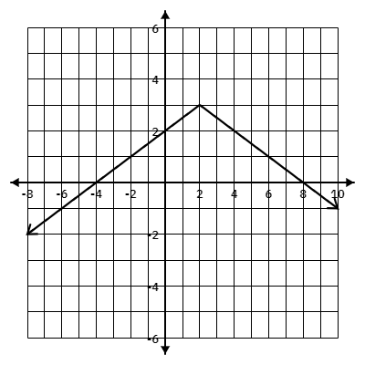
Using the graph provided answer the questions 24-28:
24. The axis of symmetry is:
A. $y=2$ B. $y=3$
C. $x=2$ D. $x=3$
25. The range of the function is:
A. $(-∞, 3]$ B. $(-∞, ∞)$
C. $(-∞, 3)$ D. $(3, ∞)$
26. The vertex of the function is:
A. $(-4,0)$ B. $(8,0)$ C. $(0, 2)$ D. $(2, 3)$
27. The y-intercept is:
A. $(-4,0)$ B. $(8,0)$ C. $(0, 2)$ D. $(2, 3)$
28. The equation of the function is:
A. $f(x)=-2\left|x-2\right|+3$ B. $f(x)=-2\left|x+2\right|+3$
C. $f(x)=-\frac{1}{2}\left|x-2\right|+3$ D. $f(x)=-\frac{1}{2}\left|x+2\right|-3$

